Unit 3 How do you get to school?
Ⅰ.Here is a big school.There are many students in it.The children are coming to school.But how do they get to school,can you find the right picture?
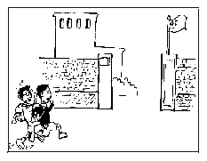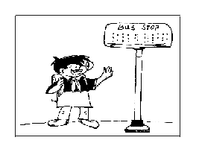
________________ ________________
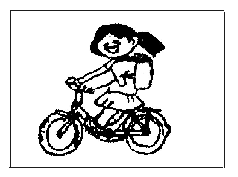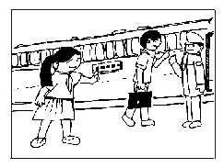
____________________ __________________
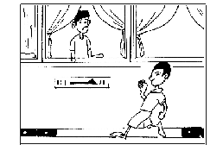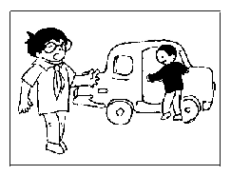
__________________ ________________
①take the subway ②take the bus
③take the train ④take the taxi
⑤ride the bike ⑥walk to school
Ⅱ.Answer the teacher's questions:
T:My home is not far from school,so I usually come to school on foot.It takes me 15 minutes.Sometimes I ride my bike.It only takes me 5 minutes.What about you?How do you get to school every day?
S:I ____________ to get to school.
T:Is it far from your home to school?
S:____________.
T:How far is it?
S:It's about ____________ miles.
S:How long does it take you?
S:It takes me ____________.
参考答案
Unit 3 How do you get to school?
Ⅰ.walk/on foot,take the bus,take the bike,take the train,take the subway,take the car

